


Yenepoya Institute of Arts Science Commerce and Management

High Level Design (HLD)
Anomaly detection For Healthcare Transaction

Student Name: Safnas A
23BSAMD029
LH08

BSc. Artificial Intelligence,
Machine learning and Data Science(IBM,TCS)

Industry Mentor: Mr. Sumit Kumar Shukla
Guided by: Ankitha Poojary Ma’am

TABLE OF CONTENTS
- Introduction ............................................. 1
1.1 Scope of the Document ............................ 1
1.2 Intended Audience .................................. 2
1.3 System Overview ................................... 2
- System Design ......................................... 3
2.1 System Architecture ............................... 3
2.2 Application Design ............................... 4
2.3 Process Flow ....................................... 5
2.4 Information Flow .................................. 6
2.5 Components Design ............................. 7
2.6 Key Design Considerations ................. 8
2.7 API Catalogue ..................................... 8
- Data Design ............................................ 9
3.1 Data Model .......................................... 9
3.2 Data Access Mechanism ..................... 10
3.3 Data Retention Policies ...................... 10
3.4 Data Migration ................................... 11
- Interfaces ............................................. 12
4.1 User Interface .................................... 12
4.2 Dataset Upload Interface ................. 13
4.3 Manual Input Interface ...................... 14
4.4 Output Interface ................................ 15
- State and Session Management ........... 16
- Caching Strategy ................................. 17
- Non-Functional Requirements ............ 18
7.1 Security Aspects ............................... 19
7.2 Performance Aspects ....................... 20
- Future Enhancements ......................... 21
- References .......................................... 22

- Introduction
Healthcare institutions process thousands of transactions such as insurance claims, treatment charges, billing records, and reimbursements. Due to the high volume of data, it becomes difficult to manually detect fraudulent or abnormal transactions. Suspicious activities such as unusually high claims, duplicate billing, or incorrect provider charges may go unnoticed.
The Healthcare Transaction Anomaly Detection System is developed to automate the process of identifying suspicious transactions using statistical techniques. The system uses Python libraries such as Pandas and NumPy for data analysis and Streamlit for creating an interactive web interface. Users can upload healthcare transaction datasets in CSV format, and the system will classify transactions into normal and anomalous categories.
This project helps improve transparency, reduce fraud risk, and support decision-making in healthcare finance management.

1.1 Scope of Document
This document provides a high-level overview of the system design, architecture, and working principles of the Healthcare Anomaly Detection System. It outlines how data flows through the system and how anomalies are detected.

1.2 Intended Audience
- Academic evaluators
- Developers and designers
- Project supervisors
- Stakeholders interested in system functionality
1.3 System Overview
The system enables users to upload healthcare claim datasets and automatically detect anomalies in claim amounts. It processes the data using statistical techniques and highlights abnormal transactions.
The system is designed to be efficient, scalable, and easy to use, ensuring accessibility for both technical and non-technical users.

- SYSTEM ARCHITECTURE

2.1 Application Design
The system follows a 3-layer architecture:

Presentation Layer
User interacts through Streamlit web interface.

Application Layer
Handles data preprocessing, anomaly detection, and output generation.

Data Layer
Stores uploaded CSV dataset

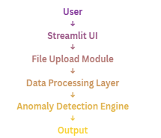
  - Process Flow
- User uploads CSV file or enters claim amount
- Dataset is loaded using pandas
- Mean and standard deviation are calculated
- Z-score is computed
- Threshold logic checks anomaly

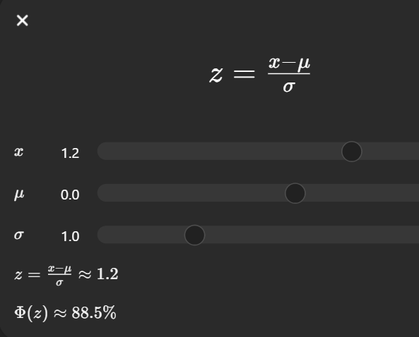
Where x is claim amount, μ is mean, and σ is standard deviation.

2.3Information Flow
The Information Flow explains how data moves through the Healthcare Anomaly Detection System. First, the user uploads a dataset or enters a claim amount through the Streamlit interface. The input data is then sent to the processing module where it is read and validated. After that, the anomaly detection module applies the Z-score method to analyze claim amounts and identify unusual transactions. Finally, the processed results are displayed to the user in a clear tabular format.
User Input → Processing → Z-score Analysis → Output
2.4 Components Design:
The system is divided into different components to improve efficiency and maintainability.
- Input Component – Accepts CSV file upload and manual claim entry
- Processing Component – Reads and prepares dataset using pandas
- Detection Engine – Applies Z-score logic to detect anomalies
- Output Component – Displays results in Streamlit interface
Each component performs a specific function and works together smoothly.

2.5 Key Design Considerations
The following factors were considered during system design:
- Accuracy in anomaly detection
- Fast processing speed
- Easy-to-use interface
- Scalability for future data growth
- Maintainability of code structure

2.6 API Catalogue
No external APIs are used in this project. All operations are performed locally using Python libraries such as pandas, NumPy, and Streamlit..
- Data Design

  - Data Model

Data | Type
Dataset | DataFrame
claim_amount | Numeric
z-score | Numeric
anomaly | string

The system uses a structured dataset containing healthcare claim details. Important fields include:
- patient_id
- provider_id
- claim_amount
- claim_date
These fields are used to identify suspicious claim transactions

3.2.Data Access Mechanism
The uploaded CSV file is accessed dynamically during runtime using pandas functions.

df = pd.read_csv(uploaded_file)
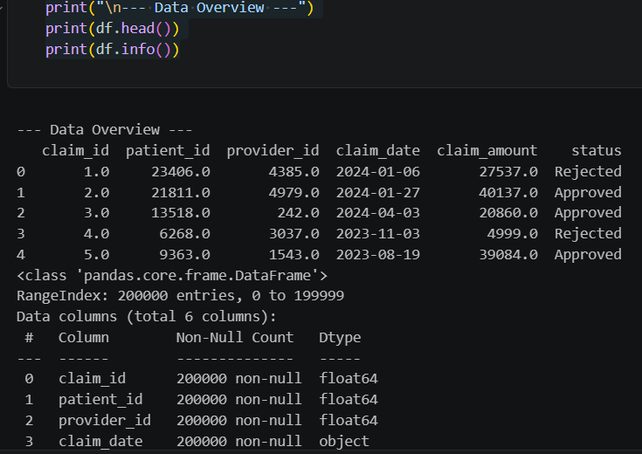

This allows quick loading and analysis of the dataset.
3.3 Data Retention Policies
The system processes data temporarily during execution and does not store it permanently. This ensures privacy and reduces the risk of data leakage.
3.4 Data Migration
Data migration is not required because the system directly works with uploaded CSV datasets.

- Interfaces
The Interfaces section explains how the user interacts with the Healthcare Anomaly Detection System. Since this project is developed using Streamlit, the interface is web-based and user-friendly. It allows users to upload datasets, manually enter claim values, and view anomaly detection results instantly.
This section is important because it shows the input methods, output screens, and interaction flow between the user and the system.
4.1 User Interface
The homepage provides:
- Application title
- Upload dataset option
- Manual input box
- Check anomaly button
- Result display section
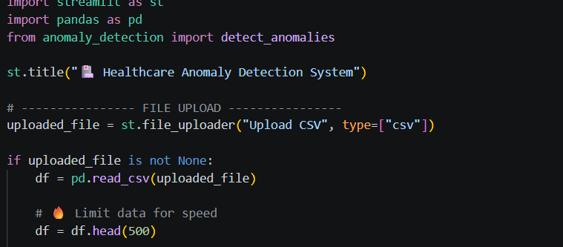
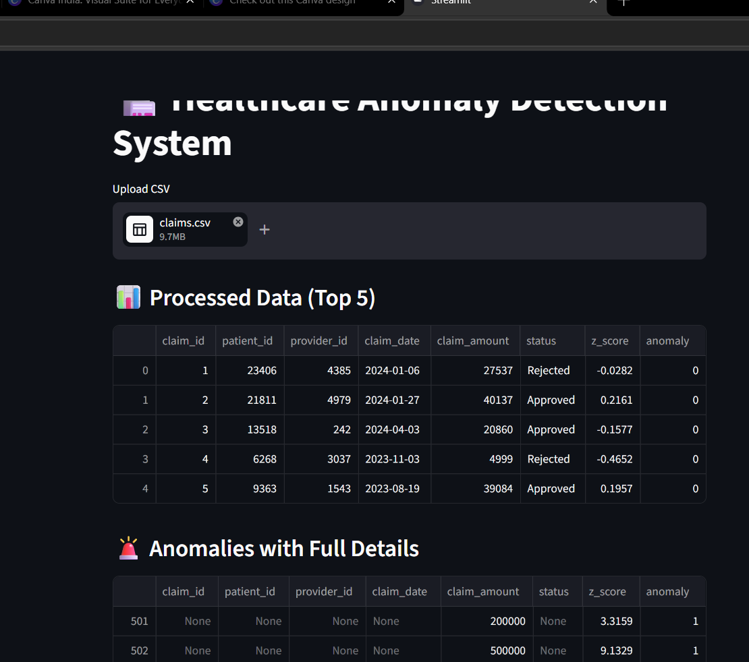
4.2 Dataset Upload Interface
This section allows users to upload CSV files for anomaly detection.
4.3 Input interface:
- CSV dataset upload
- Manual claim amount input
Description:
The system allows users to upload healthcare datasets or manually enter claim amounts for anomaly detection.
Example Input:
patient_id: 102
provider_id: 45
claim_amount: 250000
claim_date: 2024-03-12

4.4 Output Interface
Output:
- Processed dataset
- Z-score values
- Anomaly status
Description:
The system displays results clearly with anomaly labels for each transaction.
Example Output:
patient_id: 102
provider_id: 45
claim_amount: 250000
z_score: 3.2
anomaly: Yes
5. State and Session Management
State and Session Management ensures smooth interaction between the user and the Streamlit application during runtime. Since the project is web-based, the system must maintain temporary user inputs and outputs while the session is active.
Streamlit internally handles session state automatically. When a user uploads a dataset or enters a claim amount, the values remain active until the page is refreshed or restarted. This helps users perform multiple checks without re-entering data repeatedly.
Main session activities include:
- Maintaining uploaded dataset during runtime
- Holding manual input values temporarily
- Preserving output results until next execution
- Supporting multiple anomaly checks in one session
This improves user experience and makes the application interactive and efficient.
6. Caching Strategy
Caching is used to improve system performance by reducing repeated calculations. If the same dataset is processed multiple times, caching avoids reloading and recalculating data again and again.
In future versions, Streamlit caching methods such as st.cache_data() or st.cache_resource() can be implemented.
Benefits of caching include:
- Faster dataset loading
- Reduced processing time
- Better response speed
- Efficient memory usage
- Improved user experience
7. Non-Functional Requirements
Non-functional requirements define the quality standards of the Healthcare Anomaly Detection System. These requirements ensure the system performs efficiently and reliably.
Main non-functional requirements include:
- High performance
- Reliability
- Scalability
- Usability
- Maintainability
- Security
These factors improve the practical usability of the system.
7.1 Security Aspects
Security is important because healthcare data may contain sensitive information. The current project follows basic security practices by processing data locally without storing it permanently.

7.2 Performance Aspects
The system is designed to provide fast and efficient performance for small and medium-sized datasets. Python libraries such as pandas allow quick reading, processing, and anomaly detection.
8. Future Enhancements
The project can be extended further with advanced features to improve accuracy and usability.
Possible future enhancements:
- Add IQR-based anomaly detection
- Integrate Machine Learning algorithms
- Real-time fraud monitoring
- Interactive dashboard visualizations
- Cloud deployment for online access
- Role-based login system
- PDF/Excel report generation
- Email alert for suspicious claims
9. References
The following resources were used during development and research of the project:
- Python Official Documentation
- Pandas Official Documentation
- Streamlit Official Documentation
- NumPy Official Documentation
- Matplotlib Documentation
- Z-score Statistical Method Reference
- Data Science and Anomaly Detection Articles
- Online Python Community Resources
Web Links:
- https://docs.python.org
- https://pandas.pydata.org
- https://streamlit.io
- https://numpy.org
- https://matplotlib.org

